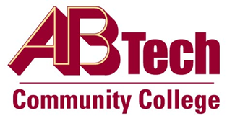

# Asheville-Buncombe Technical Community College (A-B Tech) Policy Manual

## Policy 403: Debt Collection

It is the policy of the Board of Trustees to establish procedures for collection of overpayments and account receivables over 30 days. The College may work in conjunction with the Attorney General, Department of Revenue and collection agencies.

## Scope

Refers to all past due account receivables greater than 30 days old.

## Definitions

Accounts Receivable: Amounts owed to the College including but not limited to tuition, books, fees, returned checks, financial aid reversals, return to Title IV funds, auxiliary revenues, and miscellaneous charges.

Overpayments: Salary overpayments or charges for College property withheld or damaged by an employee when the salary or property derives in whole or part from State funds.

## References

G.S. 147-86.22

NCAC 02D .0201

Reviewed by the Executive Leadership Team, June 13 and 20, 2012

Reviewed by the Attorney, June 20, 2012

Reviewed by the Board of Trustees Executive Committee, June 21, 2012

## Policy Owner

Vice President of Operations/CIO ex. 7900

See Debt Collection Procedure

Approved by the Board of Trustees on August 6, 2012.